Admin Portal Office Hours:

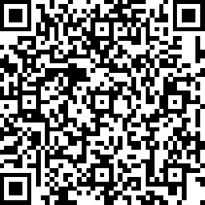

https://king-tuerto.github.io/Office-Scheduling/admin.html